**Assignment -1**

Python Programming

|  |  |
| --- | --- |
| Assignment Date | 19 September 2022 |
| Student Name | NADIPINENI BHARATH KUMAR |
| Student Roll Number | 810419104065 |
| Maximum Marks | 2 Marks |

**Question-1:**

1.Create registration page in html with username, email and phone number and by using POST method display it in next html page.

**Question-2:**

2. Develop a flask program which should contain at least 5 packages used from pypi.org

**Note:-** Following application contains (Flask , render_template ,url_for, redirect, request)

So both Questions have same Answers

**Source Code:**

**App.py**

*from* tkinter.tix *import* Form

*from* flask *import* Flask ,render_template,url_for,redirect,request

app = Flask(__name__)

@*app*.*route*('/')

def *index*():

*return* render_template("index.html")

@*app*.*route*('/success/<name>/<phone>/<email>')

def *success*(name=None,phone=None,email=None):

*return* " <h1>Registered Successfully</h1><h2>Your Details Are:-</h2>  {} <br>{} <br> {} ".format(name , phone ,email)

    # *'{} {} {}'.format(firstname, lastname, cellphone)*

@*app*.*route*("/login",methods =['POST','GET'])

def *login*():

*if* request.method == 'POST':

        user = request.form['name']

        email = request.form['email']

        phone = request.form['phone']

*return* redirect(url_for("success", name = user ,phone = phone ,email = email ))

*else*:

        user = request.args.get("input_name")

*return* redirect(url_for("success",name=user))

*if* __name__ == '__main__':

    app.run(debug=True)

**index.html**

<!DOCTYPE *html*>

<html *lang*="en">

<head>

    <meta *charset*="UTF-8">

    <meta *http-equiv*="X-UA-Compatible" *content*="IE=edge">

    <meta *name*="viewport" *content*="width=device-width, initial-scale=1.0">

    <link *rel*="stylesheet" *href*="/static/style.css">

    <link *rel*="stylesheet" *href*="https://cdn.jsdelivr.net/npm/bootstrap@5.2.0/dist/css/bootstrap.min.css"

*integrity*="sha384-gH2yIJqKdNHPEq0n4Mqa/HGKIhSkIHeL5AyhkYV8i59U5AR6csBvApHHNl/vI1Bx" *crossorigin*="anonymous">

    <title>Registration page </title>

</head>

<body>

    <form *method*="post" *action*="login">

        <h1>REGISTRATION PAGE</h1>

        <div *class*="mb-3">

            <label *for*="name" *class*="form-label">Enter the name</label>

            <input *type*="text" *class*="form-control" *id*="name " *name*="name" *placeholder*="NAME">

        </div>

        <div *class*="mb-3">

            <label *for*="exampleInputEmail1" *class*="form-label">Email address</label>

            <input *type*="email" *class*="form-control" *name*="email" *id*="exampleInputEmail1" *placeholder*="EMAIL">

        </div>

        <div *class*="mb-3">

            <label *for*="phone" *class*="form-label">Enter the phone number</label>

            <input *type*="text" *class*="form-control" *name*="phone" *id*="phone" *placeholder*="PHONE NUMEBER">

        </div>

        <button *type*="submit" *class*="btn btn-primary">Submit</button>

    </form>

</body>

</html>

**Style.css**

body{

    background-color: aqua !important;

    display: flex;

    flex-direction: column;

    align-items: center;

    justify-content: center;

}

form{

    display: flex;

    flex-direction: column;

    align-items: center;

    justify-content: center;

    background-color:#fff;

    width: 40%;

    height: 400px;

    border-radius: 50px;

    margin: 100px;

}

h2{

    font-size: large;

    font-weight:bolder;

}

input{

    width: 80% !important;

}

div{

    display: flex;

    align-items: center;

    justify-content: center;

    flex-direction: column;

    width: 90%;

}

**Output:-**

**Index Page:-**

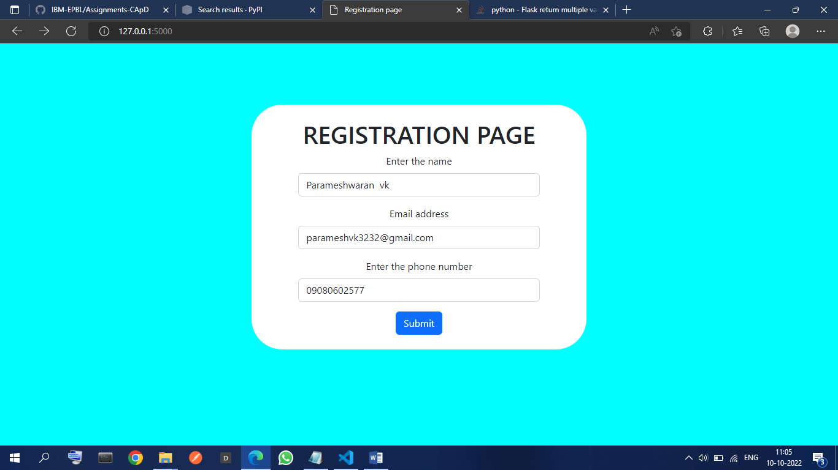

**Login successful page**

